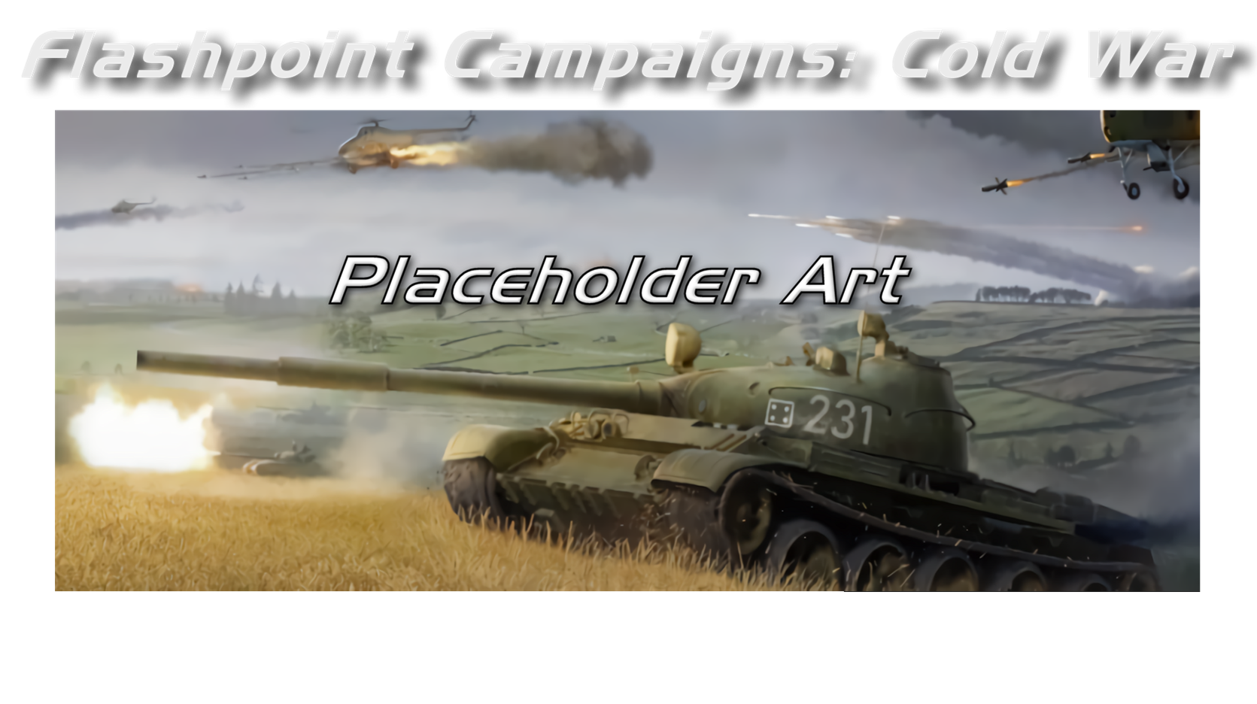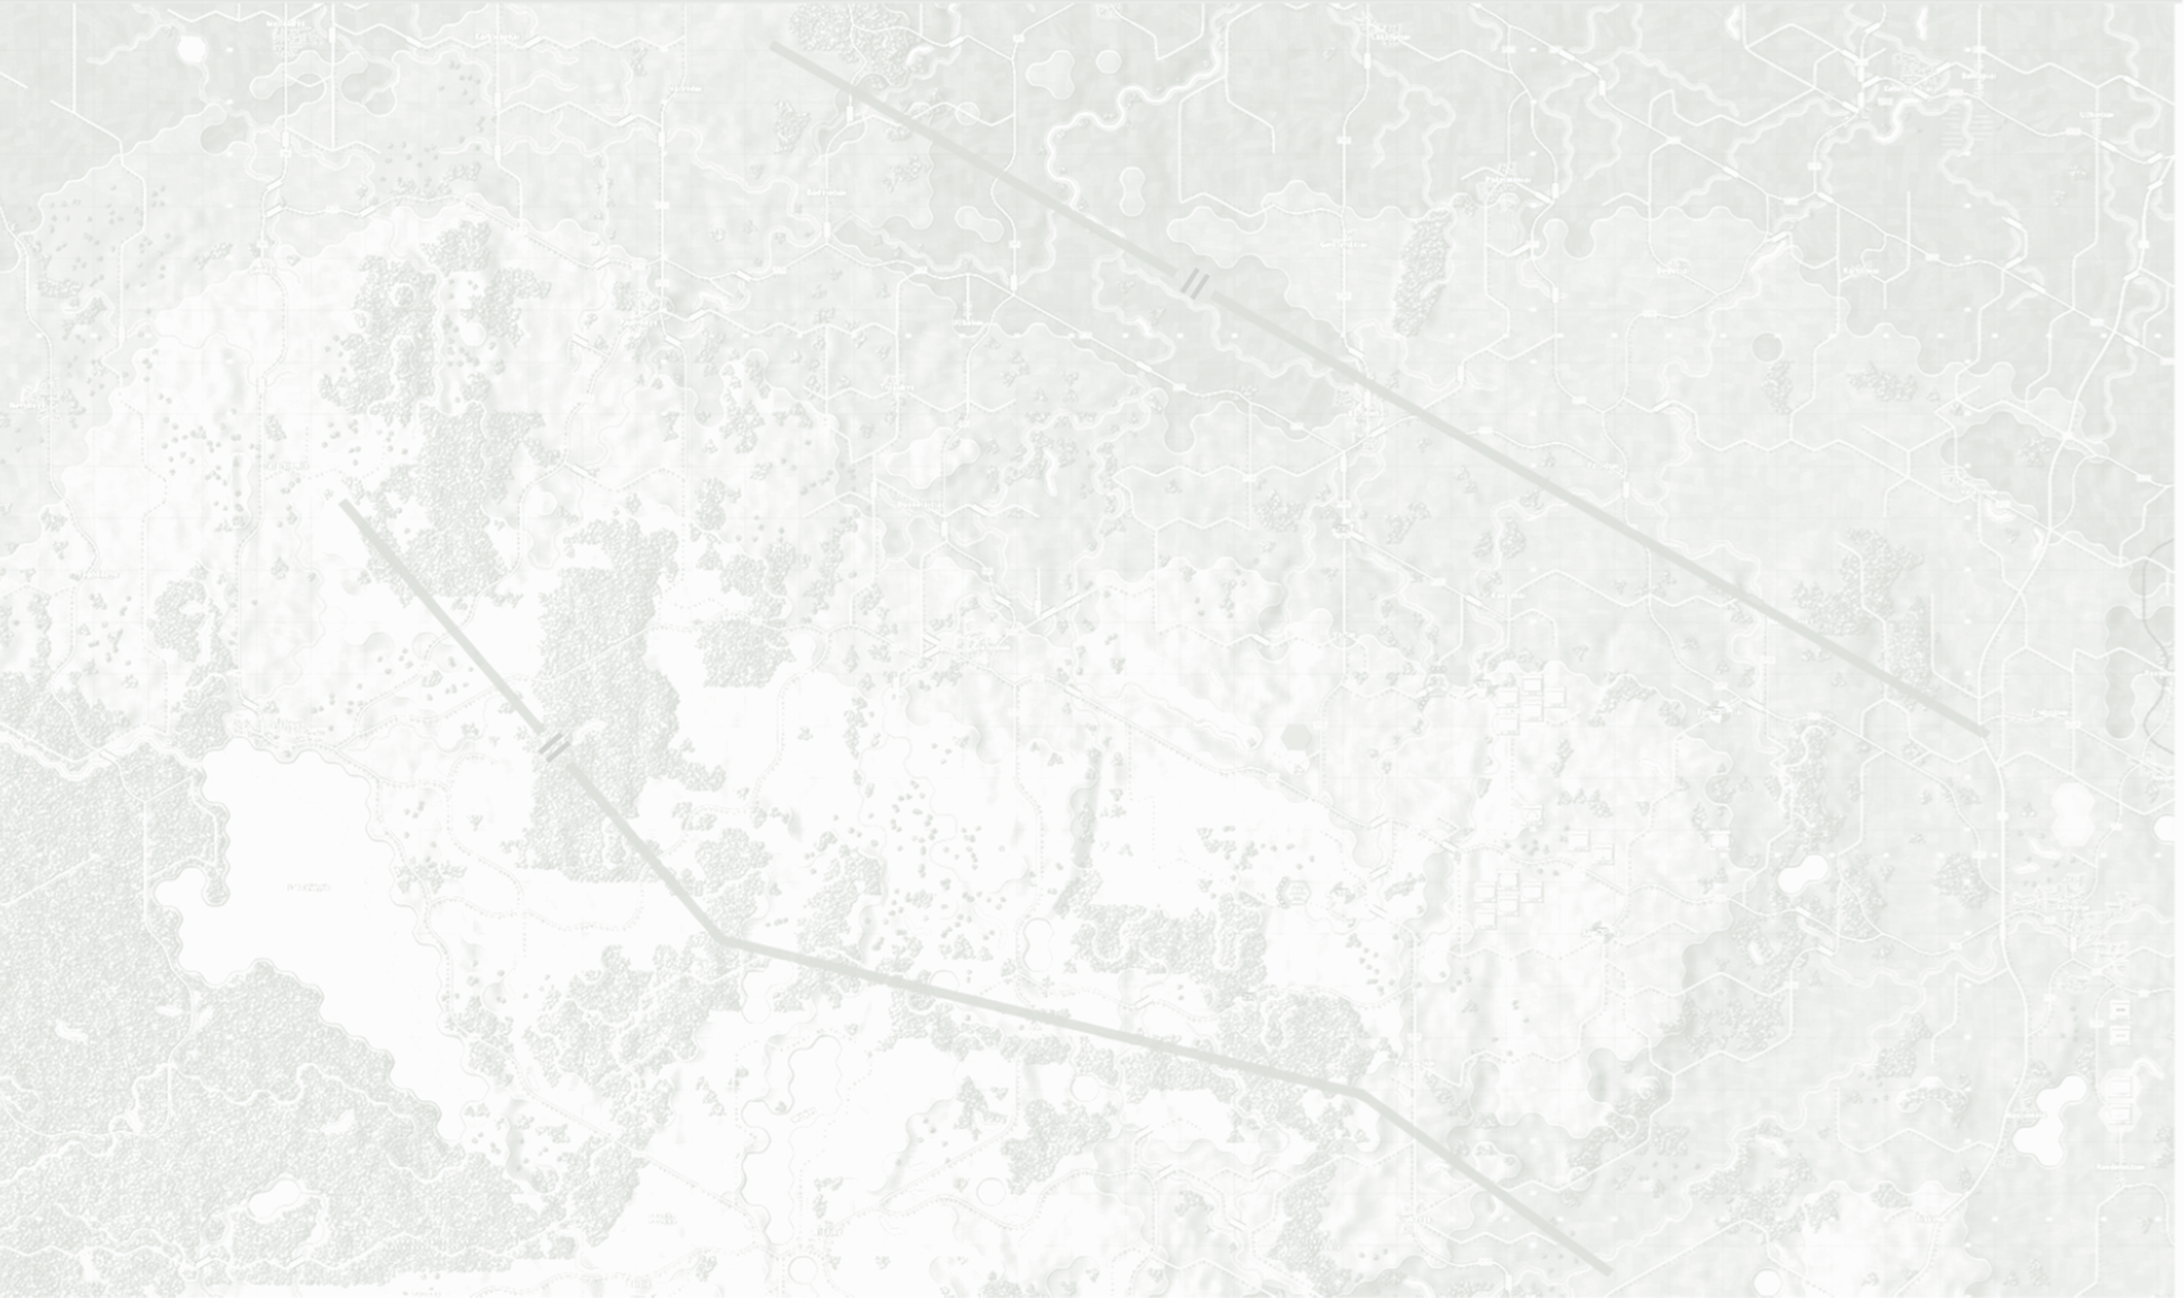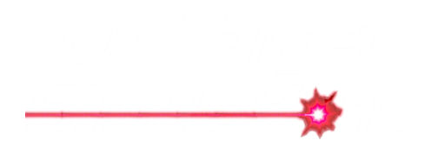

Game Engine Modifications

Field Manual FCCW-08/R1

**© 2025 On Target Simulations (OTS), LTD. All Rights Reserved. The images used and OTS Logo are property of On Target Simulations, LTD. All other marks and trademarks are the property of their respective owners.**

Table of Contents

1 Introduction 5

1.1 What's in This Document 5

1.2 Manuals 6

1.2.1 The Field Manuals (FM) 6

1.2.2 What’s New 6

1.2.3 FPC Hotkeys 6

1.2.4 Flashpoint Campaigns: Cold War FAQ 6

1.3 Gender Pronouns and Inclusion 6

2 Getting Started 7

2.1 Deciding What You Want to Make 7

2.2 New or Derived Content 7

2.3 Gathering Source Information 7

2.4 Third-Party Tools and Other Assets 7

2.5 Working with User Feedback 7

3 Replacing National Art Assets 8

3.1 Unit Silhouettes 8

3.1.1 Use 8

3.1.2 Location of Assets 8

3.1.3 Size and Format Required 8

3.2 SubUnit Inspector Images 9

3.2.1 Use 9

3.2.2 Location of Assets 9

3.2.3 Size and Format Required 9

3.3 Unit Badges/Insignias/National Flags 10

3.3.1 Use 10

3.3.2 Location of Assets 10

3.3.3 Size and Format Required 10

3.4 Counter Background Art 11

3.4.1 Use 11

3.4.2 Location of Assets 11

3.4.3 Size and Format Required 11

3.5 Flags 12

3.5.1 Use 12

3.5.2 Location of Assets 12

3.5.3 Size and Format Required 12

4 Animations 12

4.1 Use 12

4.2 Location of Assets 12

4.3 Size and Format Required 12

5 Counter Art Elements 13

5.1 Use 13

5.2 Location of Assets 13

5.3 Size and Format Required 13

6 Map Markers 13

6.1 Use 13

6.2 Location of Assets 14

7 Art Restrictions 14

7.1.1 Required Animations 14

8 Replacing Sound Assets 14

8.1 Vehicle Sounds 15

8.1.1 Use 15

8.1.2 Location of Assets 15

8.1.3 Format Requirements 15

8.2 Combat Sounds 15

8.2.1 Use 15

8.2.2 Location of Assets 16

8.2.3 Format Requirements 16

8.3 Theme Music 16

8.3.1 Use 16

8.3.2 Location of Assets 16

8.3.3 Format Requirements 16

8.4 Background Battle Sounds 16

8.4.1 Use 16

8.4.2 Location of Assets 17

8.4.3 Format Requirements 17

9 Editing Game INI Files 17

9.1 List of INI Files 17

9.2 INI File Layout 18

9.2.1 Section Headers 18

9.2.2 Data Keys 18

9.2.3 Comments 18

10 CSS Files 18

11 Sil Making 101 18

11.1 Find an Image 19

11.2 Process in the Art Program 19

12 Flashpoint Campaigns Credits 24

12.1 On Target Simulations 24

12.2 On Target Simulations Content Team 24

12.3 Cold War Beta Testers 24

12.4 Matrix Production Support 24

13 OTS on the Web 25

# A military tank in a field AI-generated content may be incorrect.Introduction

Welcome to FLASHPOINT CAMPAIGNS: COLD WAR

This is a grand tactical combat simulation on the Cold War battlefield. As the force Commander, you will plan and then issue orders and Standard Operating Procedures to your battalion, brigade, or regimental forces, shaping the fight by maneuver and your intent. Your forces will engage the enemy on rendered real-world map locations. Each hex is 500m of militarily significant terrain. Each battle can last 4 to 24 hours of in-game time. Your troops will meet their foes any time of day and in any environment.

The game engine is based on asynchronous WEGO turns. This means you will issue orders and then watch a variable amount of time unfold on the battlefield. Then, issue or adjust orders to react to what has happened as you execute your battle plan.

***Flashpoint Campaigns: Cold War*** is a deep simulation of combat operations where your forces are arranged in maneuver units of companies, platoons, and sections of tanks, infantry fighting vehicles, infantry squads and teams, recon forces, engineers, air-defense and anti-tank systems, helicopters and more. As the Commander, you must use available off-map assets like long-range artillery, rockets, or airstrikes.

Your efforts in this complex battlespace will be constantly challenged by modeled features like Electronic Warfare, Air Superiority, Realistic Weather, Line of Sight and Fire, Terrain and Elevation, Smoke and Mines, and Human Factors like training, morale, and readiness. All these elements must be considered if you are to be victorious on the battlefield.

The game is packed with information dialogs, map overlays, and range rings to aid you as Commander, master the situation, and understand your force’s capabilities.

***Flashpoint Campaigns: Cold War*** is a data-rich simulation where each nation has information on National Characteristics, Command Parameters, and Orders of Battle. Data Tables are packed with era-specific equipment and troops. Weapon Systems of the time, such as guns, missiles, precision munitions, small arms, and much more, are comprehensively modeled.

As a toolkit, you can create your own scenarios and campaigns. You can also dive deeper and create or modify game data, artwork, and sound effects as you see fit. All these modding capabilities are supported by detailed documentation.

## What's in This Document

This document provides the information necessary to modify (mod) aspects of the game’s content, such as artwork and sounds. The information discusses the use, location, and formats required for each item.

**NOTE:** All data provided by On Target Simulations LTD is gathered from unclassified, open sources and best-guess estimations from our team. ***Do not*** use information or data from sensitive or classified military sources in your mods.

**NOTE:** Areas of interest or buttons on form pictures are outlined in red.

**NOTE:** Some images in this manual are from other game versions. While your maps and units may differ, all the information and how it is used and displayed will match the information in this manual.

## Manuals

We have chosen to go with many living manuals to cover game interface/play, learning the game, basic tactics, Content Creation, and Game Modding for the Cold War game engine. We also have guides that cover that area of operations. The affected manuals and guides will be updated as the game is updated, and PDFs of these changes will be included with the new patches.

### The Field Manuals (FM)

These are the core manuals on how to play, create content for, and modify data for the Cold War game engine. Before jumping into Content Creation, we strongly recommend you review the first three manuals, **Game Operations**, **Battlefield Primer**, and **Tutorial Operations,** if you are new to this type of game and warfare. Returning Flashpoint Campaigns players should review **Game Operations** to get details on new features, as there are many.

These documents are found in the Documents\FMs folder.

* FM01: Game Operations – Detailed information on the game, its interface, and how to use it
* FM02: Battlefield Primer – Fighting in the Cold War
* FM03: Tutorial Operations – How to learn and play the game
* FM04: Scenario Design – How to make or edit scenarios
* FM05: Battle Planning – How to create or edit battle plans. Battle Planning is a unique topic of Scenario Design.
* FM06: Campaign Design –How to make or edit campaigns
* FM07: Map Construction –How to make simple maps for the game
* FM08: Game Engine Modifications – ***This Manual*** - How to Mod elements of the game engine
* FM09: Data Structures and Editing – How to edit or build data sets
* FM10: Weather Setup – How to add in weather from other locales

### What’s New

The What’s New PDFs summarize any changes and fixes when updates are released.

These can be found in the Documents\WhatsNew folder.

### FPC Hotkeys

This PDF document lists all the unique game key presses for Function keys and all hotkey definitions. Due to the large number of functions in the game, rebinding is not possible.

This document is in \Documents folder.

* + 1. Flashpoint Campaigns: Cold War FAQ

To stave off forum-clogging threads on various topics we either don't control or can't support, we created this FAQ document with the answers to those specific topics.

Please review the FAQ for answers to several game topics related to the game but not on how to play the game.

This document is in the \Documents folder.

## Gender Pronouns and Inclusion

We understand that users of all genders will play our simulation. We try to keep language in the game and manuals gender-neutral, when possible, but sometimes use the pronoun “he” to refer to the user. This is merely to streamline the writing, not to exclude anyone or note a specific gender.

The On Target Simulations team supports the inclusion of all people in the field of wargaming.

# Getting Started

***FLASHPOINT CAMPAIGNS*** is a game of grand tactical warfare as it is a construction kit with sweeping capability to make almost any modern combat situation (Post WW2) you want. Before you dive headlong into a project, you should take some time to get your ducks (or other regionally specific animals) in a row. This chapter of the guide breaks down a few critical decisions and works on getting you ready to work on the modification (Mods) you want to make.

## Deciding What You Want to Make

It may sound like a silly question, but sometimes you may not really know what you want to mod or how far or deep you want to go. Starting small and simple, in many cases, is a good idea. If you want to change many things, you should take a minute and map out everything you need to do the job. Another factor involved is the end user. Is this something for you only, or will you make this for the public to use, too? Sometimes, it helps to be familiar with the process or tools. If you are great at digital artwork and have image editing tools, maybe changing some of the game art is a better place to start than making a new database. Either way you go, you need to have a desire to do it and, in some cases, support it after it is released.

## New or Derived Content

Where do you want to start? It is no doubt easier in almost every area of the game to derive/edit existing content than to start from scratch. If you are new to modding, I would strongly suggest starting a derived type of project first. Having data or a format in front of you helps reduce the chance of making a mistake. Once you are comfortable with all the ins and outs of creating the content you want from existing materials, you can switch to making it from scratch. If you create items from scratch, make sure you are aware of and follow the rules or guidelines for formats, sizes, and ranges. Failure to stay within the set boundaries of an object can lead to game crashes and the headaches of debugging what you have done.

## Gathering Source Information

Before you launch into a project, take the time to gather supporting source information that can help you with what you are planning to do. This could range from images to maps to specifications and documents. This will be less of an issue with sounds and some art items, but a downright necessity for scenarios and data work.

## Third-Party Tools and Other Assets

Modding a game takes time, effort, and tools. Modding the items in this FM requires a few 3rd party software tools. Here is a breakdown of what you need for the specific items.

* Graphics – Painting programs that can create or edit *.bmp and *.png images
* Sounds – *.wav file editing software and sound/music creators with *.wav output.

So, if you want to edit items in those areas, you will need software to do so.

## Working with User Feedback

Once you place content online for others, you must deal with positive and negative feedback and suggestions. The best advice I can give is to be polite in your responses. Where possible, take good suggestions and work them in. At the end of the day, it is your work and your vision, and there is nothing wrong with telling someone to use the tools to modify it the way they like. It’s what we are doing!

# Replacing National Art Assets

One of the easier to implement but harder to actually produce (in most cases) is artwork for the game. Each piece of art is in a given location with a set of parameters for format and size and a specific set of options for looks. The trick is making something that either fits with the current game or with the new material you are making within the given envelope of constraints. Each of the following sections will detail those characteristics and provide some ideas of what you can do.

National Art assets are those items related to the nation-specific art elements found in the /Modules/Common/Data folders.

## A white and black flag Description automatically generatedUnit Silhouettes

The default OTS unit silhouettes are the black side view of vehicles and equipment (tanks, APCs, Aircraft, and Field Guns) on a white background and the black, light gray, and white NATO symbols for the various infantry squads seen in the game.

### Use

Each image is called out by a specific platform (AFV, Aircraft, or Infantry) in the game on the Unit Tab of the National Data file using the PICID column and a NATO symbol from the NATOPIC column. The game engine will look for the name first in the Common folder and NATO folder. If you want to override the game defaults, you can place silhouette files in the Common/Custom folder and the NATO symbol art in the /NATO/Custom folder.

The background of the PNG formatted image needs to be transparent. In the case of NATO image elements, the interior of those elements is white, but the surrounding exterior is transparent.

The unit images can be full color as well as the grayscale (we use black with grays/transparency in the edge from the anti-aliasing effect), as this works well with the Halo and Colored Silhouettes option in the game.

Platforms should face/head to the right (appear to be driving or flying left to right) in the image. The game engine will automatically flip the image for player two. This does not apply to infantry units using NATO images for their PICID that start with an underline. Any file name starting with an underline (for example: “_Inf.bmp”) will not flip direction based on the side played. All art in the NATO Folder does not flip by default for any side.

### Location of Assets

All new vehicle and equipment Silhouettes should be located in the /Modules/Common/Data/Common folder. If they are a Mod to replace existing images, they should be placed in the /Modules/Common/Data /Common/Custom folder.

All the NATO unit images are located in the /Modules/Common/Data /NATO folder. If they are a Mod to replace existing images, they should be placed in the /Modules/Common/Data /NATO/Custom folder

### Size and Format Required

A silhouette must be at least 256 pixels wide by 128 pixels tall and have a 2 to 1 aspect ratio. The game scales these images to be used in various UI dialogs and on the counters.

**NOTE:** Any image with a 2 to 1 aspect ratio will work and get scaled in the game’s UI. If the image is not in a 2 to 1 aspect ratio format, the image will appear distorted in the game. If you have 4k or larger screens, you may wish to make your art larger to maintain better detail when zoomed in.

The image must be saved as a “PNG” type file with a transparent background. Leave at least 4 pixels on the bottom and 5-10 on the sides and top as a buffer zone around the images. Aircraft and helicopters should be centered in the middle of the image with a minimum of 5 to 10-pixel buffer to the edge. This will minimize the overlap of other counter graphics.

The file name must match one or more file names in the Units Tab of the data file(s) to be used in the game. For example, to replace the image for a T-80U, you need to save your new image with the same name, “T80U.png”.

Each unit requires both a picture image and a NATO picture image in the data file. For infantry-type units, this is the same NATO artwork, but located in the two noted folders with different filenames.

## SubUnit Inspector Images

Users can add Subunit Inspector (SUI) images for each platform to replace the standard silhouette image in the SUI.

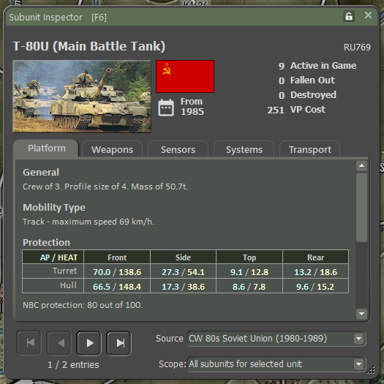

### Use

These images (in the red rectangle) will replace the standard silhouettes seen in the SUI display. They are not rotated and get as shown as saved.

If your image is smaller or larger than the image location size, the game engine will scale it to fit the image dimensions in the dialog.

### Location of Assets

All the SUI images are located in \Modules\Common\Data\<Country Name>\Unit Images folder. This will allow for using different images for the same item based on the country of origin.

### Size and Format Required

The SUI image is 256 pixels wide by 128 pixels tall at a minimum, and if larger, it should maintain the 2 to 1 size ratio to fit the image location.

**NOTE:** Any image with a 2 to 1 aspect ratio will work and get scaled in the game’s UI. If the image is not in a 2 to 1 aspect ratio format, the image will appear distorted in the game. If you have 4k or larger screens, you may wish to make your art larger to maintain better detail when zoomed in.

**NOTE:** The larger the file size, the more memory the game will use or need. Color images use more memory for images of the same size.

It must be saved as a PNG-type file. Other file formats will not be displayed.

The file name must match the current silhouette name by adding a “-S” to the unit’s name. For example, if you want to add an image for the Soviet T-80U (like above), you need to save your new image as “T80U-S.png” in the Soviet Unit Images folder.

## Unit Badges/Insignias/National Flags

Each force in a scenario can be represented with a Unit Badge. In the game, we have supplied three types. First, a stylized national flag, next, a stylized nation insignia, and finally, several unit badges or patches from actual units from each nation.

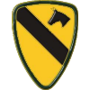

### Use

The badges are an immersion factor for the player. They are meant to provide a link to the country or force the player is fighting for. These badges can really be anything you want. Currently we went with unit patches or badges, national symbols, and flag icons.

As you will see from many of the badges, the use of the PNG format allows for transparency in the image without the use of a target color that is removed later. There does appear to be a case with the image container in the game engine that will take some colors and make them transparent based on the pixel in the lower left corner of the image. If this causes a problem with your image, I suggest erasing the 4 corner pixels or making a one-pixel transparent border around the image. In our case most of the badges have some 3d effect and shadows to give then a “pop” on the screen. You can make your any way you want.

Each badge/flag/insignia is located in Badges folder. If you want it to be available for selection in scenario construction or in-game avatar selection (same dialog is used for selection) it must be in every country folder, you want it to appear for.

If your image is smaller or larger than the 100 x 100-pixel size, the game engine will scale it to fit the window.

### Location of Assets

All the Badges are located in /Modules/Data/<Country Name>/Badges folder.

### Size and Format Required

A badge must be 100 pixels wide by 100 pixels tall minimum. If made larger, the 1 to 1 aspect ratio must be followed of the in-game image will be distorted.

**NOTE:** Any image with a 1 to 1 aspect ratio will work and get scaled in the game’s UI. If the image is not in a 1 to 1 aspect ratio format, the image will appear distorted in the game. If you have 4k or larger screens, you may wish to make your art larger to maintain better detail when zoomed in.

**NOTE:** The larger the file size, the more memory the game will use or need.

It must be saved as a “PNG” type file.

The file name can be any name you wish to identify the badge. The shorter the name, the better it will appear in the Avatar Selection dialog.

## Counter Background Art

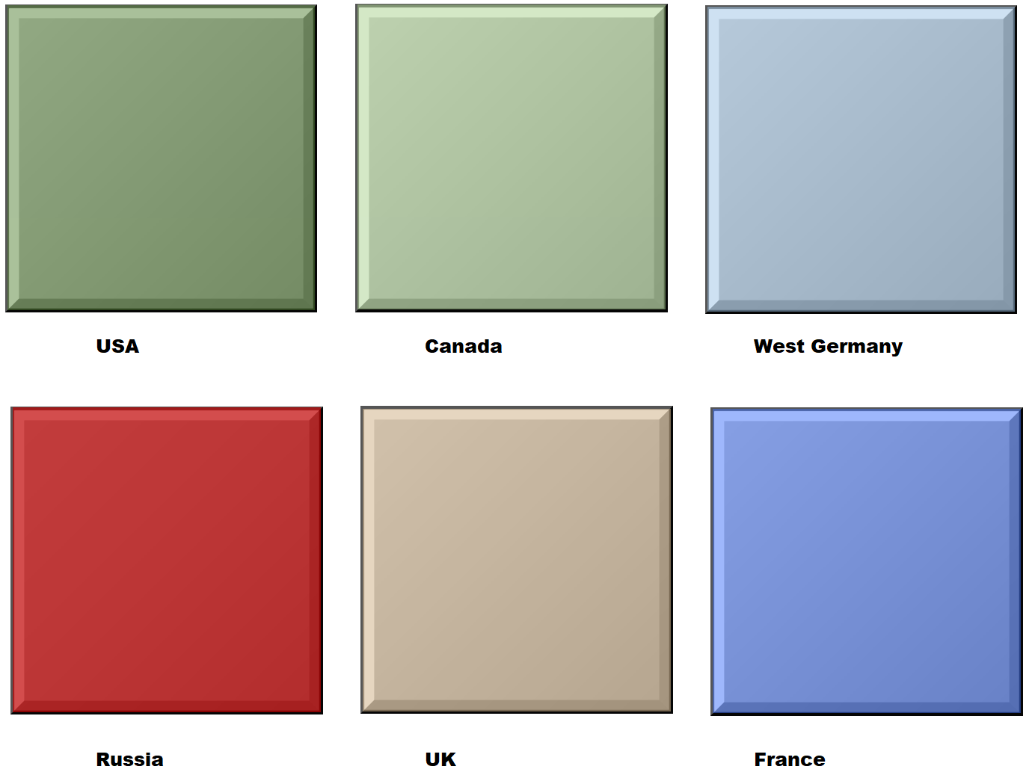Every Nation has art for the counter background that needs to convey the country of origin based on the color scheme used.

### Use

This art is used for the counter background and is an image file allowing the users to modify or create their own for each nation. We added in our versions with a more pronounced 3d edge and a bit of a gradient color change across the counter. If you decide to make your own, you need to be aware of the following:

* The existing location of the text and symbols as well as the silhouette cannot be moved.
* The existing black and white text is hard coded and cannot change. The larger white text does have a black outline to help stand out, but the smaller black unit designation text is too tiny for a white outline. If you choose colors that are too dark or use too many colors, you run the risk of washing the text out or making it too hard to read.
* Less is more. A simple single color or a simple stripe is better than a full color image of some kind.
* You can add graphic elements to the background. We did a subtle maple leaf imprint for the Canadian counter background and in another case small unit badges were added to the single-color background for US units. Again, less is more, and you must keep the counter information visible.

### Location of Assets

Counter Backgrounds are located in /Modules/Data/<Country Name>/Backgrounds folder. The currently selected default background needs to be stated in the National tab of each data file. If missing the game will generate an error.

### Size and Format Required

Counter Background art must be 300 pixels wide by 300 pixels tall and color. Larger images can be used, but a 1 to 1 aspect ratio needs to be maintained to avoid a distorted counter image in-game.

**NOTE:** Any image with a 1 to 1 aspect ratio will work and get scaled in the game’s UI. If the image is not in a 1 to 1 aspect ratio format, the image will appear distorted in the game. If you have 4k or larger screens, you may wish to make your art larger to maintain better detail when zoomed in.

**NOTE:** The larger the file size, the more memory the game will use or need.

It must be saved as a “PNG” type file.

The file name can be anything you want. We do recommend using something that uses the nation’s name or code to be easily recognized. To use it in game, the name must be entered into the National tab of the data file you are using or to replace the ones used by OTS files, the graphic must use the same name as the existing default background. I would strongly suggest backing the original art file up for a rainy day.

## Flags

These are art files used that place a nation’s flag in a number of places in the UI for identification purposes.

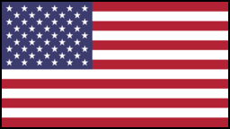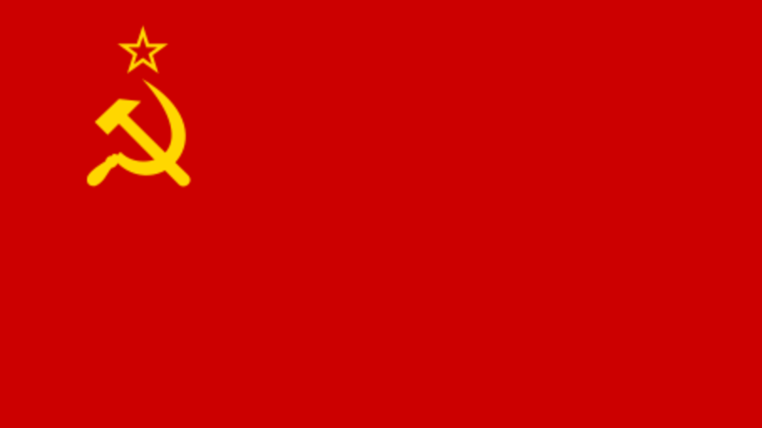

### Use

This art is used primarily in the Scenario/Campaign selection screen to filter items by nation, In the Subunit Inspector and on the Commander Panel on the main screen.

### Location of Assets

Flags are located in /Modules/Data/<Country Name>/Flags folder. Each nation needs one flag for the game to show it. If missing, the game may generate an error.

### Size and Format Required

Flag art must be 256 pixels wide by 144 pixels tall and color.

**NOTE:** Larger images may be used, but we have not tested if the game UI will scale them in all places.

It must be saved as a “PNG” type file.

The file name can be anything you want. We do recommend using something that uses the nation’s name or code to be easily recognized. The game will select the first flag it finds in the Flags folder.

**NOTE:** There is no need to have more than one flag file in the folder as only one is needed for the UI.

# Animations

While the game engine is basically 2D, we do have a few animations for various effects to add some action.

## Use

These animations are mainly short lived and small in size. Most of these are related to combat actions like shooting or explosive effects.

## Location of Assets

Animations are located in /Modules/Common/Animations folder. These assets are used by the game engine for the type of actions noted by the filename.

## Size and Format Required

Users cannot add new items to this folder. If you wish to change the any animation in this folder, you must do the following:

* Use the same name
* The art element must have the same size for height and width in pixels and the same name and number of frames and duration
* The animation frames should be PNG files with transparency
* The files must be saved into a ZIP file with the same name

**NOTE:** Making an animation too large or small, too long or short, or misspelling the name of frames or the file can result in a game engine crash.

**NOTE:** If you plan to make new animations, it is advised to back up the originals to a new location.

# Counter Art Elements

These are the art elements used on counters to denote various types of information relating to the unit’s size, type and directions of movement, selection, emitting radar, spotted, transporting, status, and subunit status.

## Use

Most of these are found on the counters on the main map and the subunit status markers are seen when viewing dialogs that show a unit’s composition.

## Location of Assets

Counter Art Elements are located in /Modules/Common/Counters folder. All counters in the game use these assets.

## Size and Format Required

Users cannot add new items to this folder. If you wish to change the any art element in this folder, you must do the following:

* Use the same name
* The art element must have the same size for height and width in pixels
* It must be saved as a PNG file with transparency

**NOTE:** Making an image too large or small or misspelling the name can result in a game engine crash.

**NOTE:** If you are planning to make new images, backing up the originals to a new location is advised.

# Map Markers

These are the various markers seen on the map other than counters. They show everything from losses, craters, obstacles, smoke, NBC effects, victory locations, and more. Each one of these items can be modified with a new image placed in the Custom Folder.

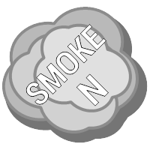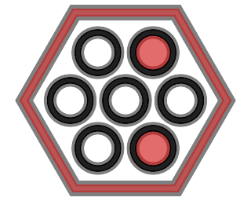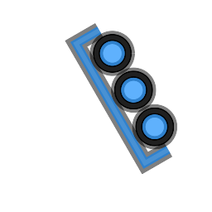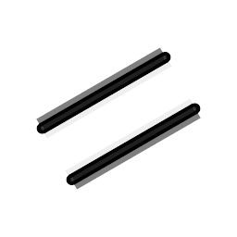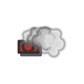

## Use

Most of the map markers are placed when designing the scenario. This includes the following:

* Bridge Markers (including side-based engineering bridges)
* Chemical and Radiation Markers
* Improved Positions (IP) Markers
* Minefield Markers (full hex and edge)
* Obstacle Markers (full hex and edge)
* Victory Point Location (VP) Markers

Some of the markers are placed by the game engine during orders resolution. This includes the following:

* Kill Markers (vehicles and squads)
* Chemical and Radiation Markers
* Crater Markers
* Gas and Smoke Markers

The Gas and Smoke marker images have full image transparency so the map underneath will show through somewhat giving the effect of real smoke.

VP markers will have the cost(s) of the hex placed in the center of the box seen on the graphic.

## Location of Assets

All of the defaults OTS Map Markers are located in /Modules/Common/Map Markers folder. If you make a new custom marker(s) they should be placed in the /Assets/Map Markers/Custom folder with the same filename. Any markers in the Custom folder will be Size and Format Required

The size of the image can vary based on its function in the game. We recommend staying within the size of the marker you wish to replace. If you go beyond or below the existing size the marker will bleed over into other hexes or be distorted or too small to see.

The images must be saved as a PNG type file. This will preserve any transparency in the image.

The file name must match the one in the folder exactly to be used by the game engine. Craters have been given a unique ability to be randomly used when needed by the game engine. If you name your images “CraterX.png” where X is a sequence of numbers from 1 to some number (in our case 5), the game will select one at random when artillery or airstrikes it a hex.

# Art Restrictions

The above art elements may be modified or replaced freely. What is prohibited from being modified are the OTS, Matrix, and other logos in the game. Also, the Flashpoint Campaigns Splash Screen must also not be altered or used in any way without permission from On Target Simulations and Matrix Games. If you create a module-level mod, you can place your own splash screen in the module’s root folder for viewing during module selection (if available).

### Required Animations

The game’s starting or Logo-based animations, including the opening credits, may not be altered in any way, nor should they be removed. The game’s use of these items is hard coded, and unexpected results could arise if files are missing, mislabeled, or altered in format.

**NOTE:** Based on the Game Engine Version, these Introduction animations may not be included.

# Replacing Sound Assets

Flashpoint Campaigns has several music and sound effects built into the game engine to add to the atmosphere of the battle raging on the screen. You can replace these sounds if you follow the format options below and, in many cases, add more sounds to increase the variety of effects heard in-game. If you decide to replace our sounds, I suggest saving them in another folder so they can be recovered if something fails to work with your sound effects.

Apart from the two themes, all other sounds are played only during turn resolution when the action is being played out on the screen.

## Vehicle Sounds

Every vehicle type used in the game and found in the data files has a sound effect for it that is heard when the unit is moved in game. These sound effects add to the overall atmosphere of the game.

### Use

The following list is all the current movement sound types used in the game based on the mobility type of the unit.

* armcar.wav, helo.wav, leg.wav, jet1.wav thru jet5.wav, track1.wav and track2.wav, truck.wav, ssm.wav, screw1.wav, screw2.wav, and prop1.wav and prop2.wav

These sounds are hard coded based on the mobility type of the unit. To replace them, you must use the same file name and replace the existing sound file. We would recommend backing up the default Vehicle sound files to another folder so they can be recovered in case the new sound file does not work.

Each movement sound should be about 1 second long and not longer than 3 seconds. Any longer and you may get delays in gameplay or unexpected sound play in-game. Test the sounds to make sure you are now getting overlapping plays in the action is fast on the screen.

The volume levels are controlled in the game options.

### Location of Assets

All vehicle sounds are located in the /Modules/Common/Audio folder.

### Format Requirements

It must be a WAV-type file to work with the game engine. No MP3s or OOGs.

The Bit Rate must be 512kbps. Other bit rates may work. If you choose a setting and hear no audio, try another bit rate.

WAV files are also recorded for Stereo output.

The file name must match the name in the list above. There is no file name link in the data file for movement sounds since they are based on the mobility class of the unit and hard coded to the given sound.

## Combat Sounds

Every weapon type used in the game and found in the data files has a sound effect that is heard when the weapon is fired in the game. These sound effects add to the overall atmosphere of the game.

### Use

The following list is all of the current combat sound types used in the game.

* Weapon Sounds: agl.wav, atgm.wav, auto cannon.wav, blast.wav, bomb.wav, flak gun.wav, flame.wav, gat.wav, HSA.wav, hvy arty.wav, LSA.wav, med arty.wav, missiles.wav, mortar.wav, MSA.wav, rpg.wav, sam.wav, tank gun.wav, HvyArtyStrike1.wav, and LtArtyStrike1.wav.
* General Combat Sounds: airstrike.wav, hit.wav, miss.wav, nuke.wav, and AC_Crash.wav sounds.

For each sound type, there may be more than one sound file. This is the case for most of the weapons and a few of the general combat sounds. If there are multiple sounds, each name will have a numeric value added to the filename. For example, HSA1.wav and HSA2.wav are two of the Heavy Small Arms files used. We have added many different sounds for the same type of weapon to have a variety of sounds during a battle. You can replace any or all of our sounds in the Audio folder. Just place your modified sound files in the Custom folder using the same names as the files in the Audio folder, and those sounds will be used instead. Just remember to back up the originals in case any problems arise.

Each combat sound should last no more than 1 second. It is a good idea not to make them longer than they are now. Overextending the sounds could lead to dropped sound effects or other unwanted behaviors from the audio.

The volume levels are controlled in the game options. Care should be taken to try to match the existing volumes and not have sounds of the same type with widely varying volume levels.

### Location of Assets

All combat sounds are located in the /Modules/Common/Audio folder.

### Format Requirements

It must be a WAV-type file to work with the game engine. No MP3s or OOGs.

The Bit Rate must be 512kbps. Other bit rates may work. If you choose a setting and hear no audio, try another bit rate.

WAV files are also recorded for Stereo output.

There are two ways to create/replace the existing combat sounds.

* You can replace the existing file with a new sound with the same exact name. These sounds will play for any scenario that uses the standard sounds.
* The path of more work would be to change the sound filename of a specific weapon in the data files and then add the new sound file to the Audio folder. These sounds will only work when new scenarios are made using the modified data files.

## Theme Music

The game has two pieces of theme music. One gets the blood flowing before the fighting begins and the other sets a calmer and serene atmosphere to review the day's destruction.

### Use

The Main Theme starts when the game is loaded and loops through until a scenario is started.

The End Theme is played during the post-mortem of a scenario.

The volume level is controlled in the game options.

Both pieces of music last around 3 minutes. You can replace it with any length music file you like, but wav files get large quickly (about 10mb-20mb per minute based on the sample rate used).

### Location of Assets

Both themes are located in /Modules/Common/Audio folder.

### Format Requirements

It must be a WAV-type file to work with the game engine. No MP3s or OOGs.

The Bit Rate must be 1411kbps and use a 16-bit format. Other bit rates and bit formats may work, but as we found out after launch, specific OS versions and codices may not work together with non-standard bitrates. If you choose a setting, hear no audio, or generate a crash in the game engine, try another bit rate or bit format.

WAV files are also recorded for Stereo output.

The file name must match the one in the folder strictly to be used by the game engine or risk them not playing or generating an error.

## Background Battle Sounds

The game has three sound files that create the sounds of distant combat as an ambient effect. They are a mix of various weapons and movement sounds.

### Use

Each battle background lasts around 1 minute. You can replace it with any length file you like, but WAV files get large quickly (about 3 MB per minute at 512kbps sample rate). To replace them, you must use the same file name and replace the existing sound file or place your sound file in the Custom folder with the same name as the original. We would recommend backing up the original Background Battle Sounds to another folder so they can be recovered in case the new sound file does not work.

The volume level for the background sounds is controlled in the game options.

### Location of Assets

Background Battle sounds are located in /Modules/Common/Audio folder.

### Format Requirements

It must be a WAV-type file to work with the game engine. No MP3s or OOGs.

The Bit Rate must be 512kbps, but other bit rates may work. If you choose a setting and hear no audio, try another bit rate.

WAV files are also recorded for Stereo output.

The file name must be “Battle_backgroundX.wav” to be used by the game engine (we use Battle_background1.wav through Battle_background3.wav in-game). The game will randomly play one of them at random times during the scenario. The name of the new file must match one of the existing ones to work. As noted above you can also place your modified file in the Custom folder to play instead of the defaults.

# Editing Game INI Files

The game has several INI files that store certain information used by the game to track options, setting, colors, line widths, and a host of other functions. In some cases, changing these may be easier than doing them in-game or may be helpful to change colors or transparency of overlays to colors the player finds easier to work with. While these files are easy to open and edit in a text editor, as the following warning notes, you can break the game.

**NOTE:** We will not be defining every value seen in the ini files in this document. The entries are, for the most part, self-explanatory. We will note what each files covers and which ones not to mess with if you want your game to work right.

**WARNING:** Making incorrect entries or incorrect formats (text instead of an integer, can cause the game to crash and be almost impossible to find. If you are not comfortable editing ini files don’t mess with them. If you are, make backups and use them if things crash.

**WARNING:** These files WILL get overridden by updates when there are changes or new values added to the game by the development team. If you really want your changes, please make copies and note what information you have changed, so you can update the file(s) when needed.

## List of INI Files

Here is a listing and explanation of what is found in each INI file.

* flashpoint.ini – This INI file covers the majority of the games options and player settings. In some cases, changing settings may be faster here than in the games dialogs, but the dialogs are less risky as typing errors can crash the game.
* Line-of-Fire-Animations.ini – This INI file holds the parameters used to render the various weapon firing effects. This file might be worth making changes depending on how you like the look of the default firing animations. Easy things to adjust here are line thickness and color or projectile size and colors.
* log_settings.ini – This INI file is used to track the setting found in the radio log. Highly recommended to not edit this file unless you really know what you are doing and want to make changes.
* overlays.ini – This INI file sets all the parameters for the various game overlays. Several things you may wish to change in this file depending on taste. Font, Text Color, colors of various overlays, and width of lines. Most of the overlays can be adjusted in the game options, but some lesser used overlays are only accessible in this INI file.
* unit_counters.ini – This INI file sets the colors for the default black or white unit silhouettes. All color artwork is done automatically. There is really nothing here to edit unless you plan to change the black and white defaults to some other colors.
* PathFlavors.ini – This INI file holds various path finding parameters used by the game to move units on the map. While this particular INI file is well documented with comments, it is most likely to break the game if you give it a value the game does not like. Make a backup in case things break or you may find yourself reinstalling the game.

**WARNING:** Just to say it again, be very careful making changes to this file. Start small. Test a lot. Have a backup.

## INI File Layout

The following sections cover the basic layout found in the INI files and any Notes or Warnings resulting from editing these files.

### Section Headers

A Header is a word found in “[]” in the INI files and is used to note the function or use of the following entries. These are keywords used in the code to pull data from the named items that follow.

**WARNING:** You should not alter, edit, or delete these entries as the game can and will crash. You may not add new Headers either, as there is no supporting code. Basically, leave them alone.

### Data Keys

After the Section Header there can be lines with Data Keys. These Data Keys are of the formation of “Key Name” = “Value”. The Key Name is a value set by the programmers and should not be altered as the game will be looking for the Key Name to function. The “=” sign is also mandatory and should not be changed or altered. What you can change is the Value parameter as long as you keep to the same type of class of value. These values can be one of the following:

* String – This is some alphanumeric entry like “Roboto”, “ProjectileSpeedM”, or “Every Cat is Black at Night”.
* Integer – This is a +/- value 0 to 65000 like “268” or “1000”.
* Boolean – This is true or false entry with entries like “True” or “F”. In some cases, this can also be a “0” for false and “1” for true.
* Hexadecimal Color Code – This is in the format of “0x12345678” where 12 is the alpha channel value (Transparency – ff = solid and 00 is clear), 34 is the two digits for Red, 56 is the two digits for Green, and 78 is the two digits for Blue in the Line of Fire Animation and “#123456” in Overlays with 12 for Red, 34 for Green, and 56 for Blue. NOTE: Valid Hexadecimal digits are 0-9 and A through F.

### Comments

These are notes that help explain the values for uses for the various entries. These must start with a “;” and space and then any info you want to add. This is a great way to record changes you make and note the original value. For example: *; Changed VaporLineWidth from 10 to 13 – 4Jan25.*

**WARNING:** Do not add comments after Values or Headers as these will cause the items to not be read and result in crashes. Place Comments above or below the line you wish to comment on.

# CSS Files

We have many CSS files in various locations in the game folders that set parameters for several of the dialogs and other elements of the game UI. We are not going to list them here as they really should not be messed with as it can wreck the UI and cause crashes. If you are adept at HTML 5 and understand the layout and use of CSS files, you can try to do edits.

**WARNING:** Editing CSS files can crash or mess up the UI and make the game unplayable. Again, if you want to try it, make backups and be very careful with what you change.

# Sil Making 101

This is a quick step-by-step on making a unit sil (silhouette) using an image from the internet and third party paint tools, in this case Corel PaintShop Pro 2023 (others may work as well if they have similar tools).

## Find an Image

Made a lot easier these days with the internet and a search engine. In this example we are going to do a BMP-2. We are looking for an image with the following qualities:

* Width greater than 256 pixels with 512 or greater being preferable to capture details.
* A clean side view of the vehicle.
* Already blacked out is a plus, but an image with a single color background or transparent makes life easier.

**NOTE**: In some cases, certain hard to find units may require taking a real image and cleaning the background out and making some other adjustments to get a decent side view.

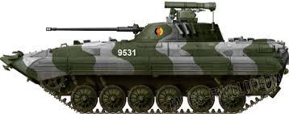

Here is a good BMP-2 image from the internet.

## Process in the Art Program

Here are the steps and tools I use with PaintShop Pro to get to a final sil for the game. With good images I can make a sil in about 30-45 seconds with all the tools on the pallet.

1. Copy and paste or save and load the located image into the paint program.

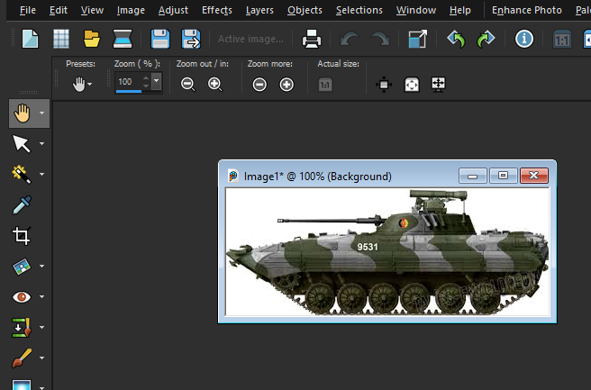

1. Using the Magic Wand Selection Tool, click on the white (solid color) to select the background.

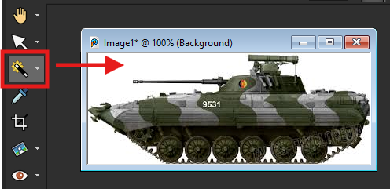

1. Invert the selection to isolate the unit in the image. If there is a color on the unit the matches the background, in this case the white numbers, those will get “removed” and we will have to fill that area in later in the process. You could also just “paint” over the numbers with a non-white color before inverting to also deal with the issue.

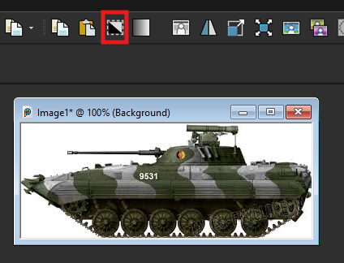

1. Now select the Copy button to grab the isolated unit image and then hit Paste (New Image) to place the background removed image in a new image window to work on further.

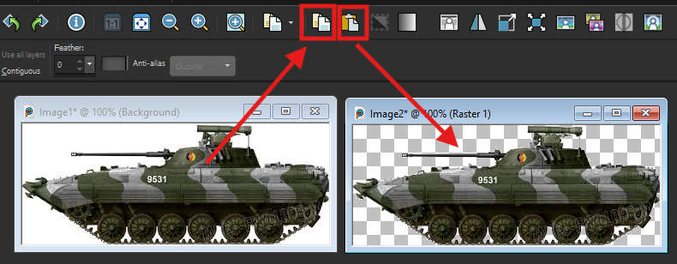

1. With the new unit image selected, select the Lighten/Darken tool, then darken the image until it is all black. As we noted you can see some of the white numbers on the hull of the vehicle. To remove this, select the paint brush and pain over the area in black (RGB: 0/0/0).

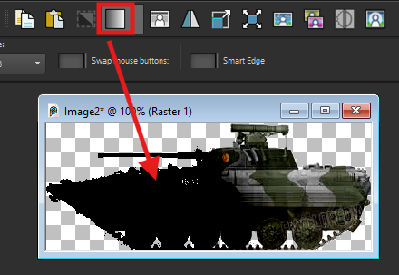

1. Next, Select Grey Scale to reduce the color pallet down to grayscale and reduce the memory required to save the image.

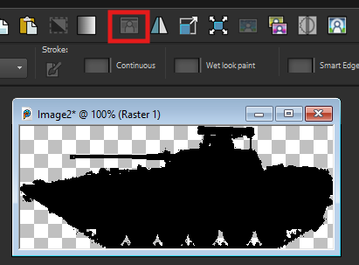

1. Now we need to face the image to the right. The game automatically sets the direction based on the side in the game. Click the Flip Horizontal tool to face the image to the right.

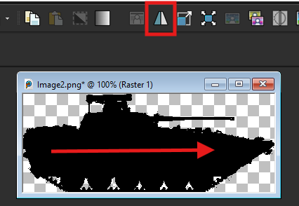

1. Next, we need to scale the image to fit to the counter. Click on the Resize tool (Red Box) and open the dialog. In the Width field (Blue Box) set it to 236 pixels. Allow the height to auto change with the Aspect Ratio locked. If the Width (Gold Box) is greater than 110 pixels set it to 110 and let the height scale (less than 236 and this is okay).

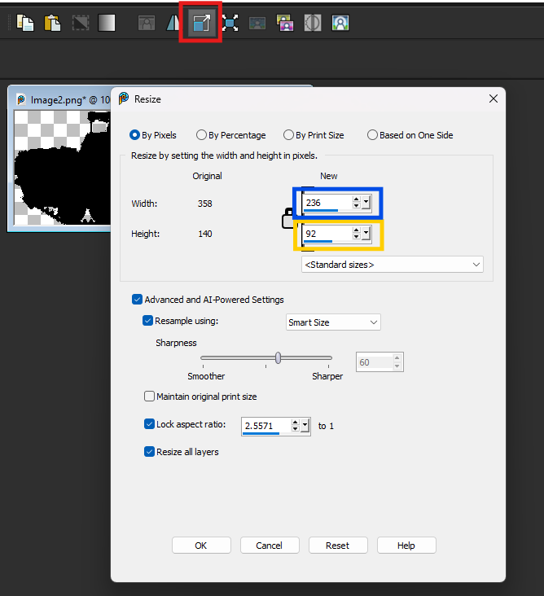

1. Now we need Resize Canvas to place and center the image. Click Resize Canvas tool (Red Box) and open the dialog. Make sure Lock Aspect is unchecked. Set the Width to 256 pixels and the Height to 128 pixels (Gold Box). For Placement (Green Box), select bottom center. In the Bottom field (Blue Box) set it to 4 pixels. This will set the final size for the unit image.

1. Here is the image after the Resize Canvas. Note the 4 pixel spacing under the vehicle.

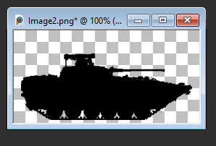

1. Now select the Save As button and save the final image in PNG format and with a name that describes the vehicle well for later use in the data files. In this case, “BMP2AT5.png” will work well. Save the image in the Common/Data/Common folder if it is to be used in the game.

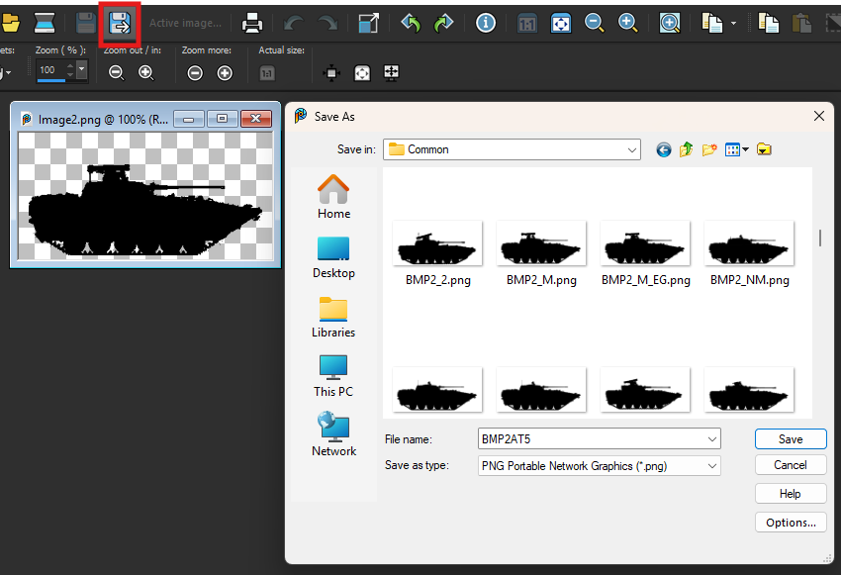

We are done and ready to do the next image. Good luck!

# Flashpoint Campaigns Credits

## On Target Simulations

* Lead Programmer and Head Honcho: **Robert "Ironman" Crandall**
* Data, Programming, Graphics, and Sound: **Jim "Cap’n Darwin” Snyder**
* Programming, Data, Models, and Research: **Jeff “Iron Mike” Sugden**
* Map Master, Programmer, AI, and Graphics: **William van der Sterren**
* Quality Czar and Testing Lead: **Charles “The Whip” Belva**
* Programming: **Kevin “SgtZDog” Zemon, Will Jackson, Alex Kriesel**
* Testing: **Tomasz Niedzinski**

## On Target Simulations Content Team

* Alexander “Stimpak” Schwarz, David “22sec” Whitt, Mike “MikeJ19” Johnstone, Joao Lima, Jurrie van der Zwaan, John “JohnO” Osborne, Jorgen “Jotte” Torgersson, Jo van der Pluym, Scott “WABAC” Gibbs and Steve “Mad Russian” Overton

## Cold War Beta Testers

* Names to added at release

## Matrix Production Support

* **Erik Rutins, Maxim Klose-Ivanov**

# OTS on the Web

Matrix Games Forum: <https://www.matrixgames.com/forums/viewforum.php?f=10149>

Check Us Out on Discord: <https://discord.com/channels/911711314051739659/911711314257248331>

Check Us Out on Steam: *“Pending a page URL*”

**© 2025 On Target Simulations (OTS), LTD. All Rights Reserved. The images used and OTS Logo are property of On Target Simulations, LTD. All other marks and trademarks are the property of their respective owners.**